**Question 1: What is the difference between 'Paste' and 'Paste Special' in Excel? Briefly**

**explain with examples.**

In Excel, both Paste and Paste Special are used to insert copied data, but they differ in flexibility and options.

**Paste**

* **Function: It directly pastes everything — values, formulas, formatting, and comments — exactly as copied.**
* **Example:  
  If you copy a cell =A1+B1 and paste it into another cell, Excel pastes the formula (=A1+B1) itself**

**Paste Special**

* **Function:** It allows you to paste **specific parts** of the copied data — like only values, only formats, only formulas, etc.
* **Example:**  
  If you copy a cell =A1+B1 and use **Paste Special → Values**, Excel pastes only the **calculated result**, not the formula.

**Here’s an example in excel of what paste and paste special actually does:**

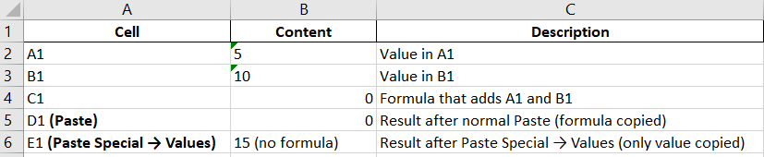

**Question 2: Describe the functions and usefulness of 'Freeze Panes' and 'Split Panes' in Excel.**

**1. Freeze Panes**

* **Function:** It keeps specific rows or columns **visible while scrolling** through the rest of the sheet.
* **Usefulness:** Helps you keep headers or labels always in view for easy data reference.
* **Example:**  
  Suppose row 1 contains column headers (like *Name, Age, Salary*).
  + If you go to **View → Freeze Panes → Freeze Top Row**, the header row will stay visible even when you scroll down.

**2. Split Panes**

* **Function:** It divides the worksheet into **separate scrollable sections (panes)**, allowing you to view and compare different parts of the sheet simultaneously.
* **Usefulness:** Useful for comparing data far apart in the same worksheet.
* **Example:**  
  If you **split** a sheet at row 10 and column C, you can scroll the top and bottom (or left and right) parts independently.

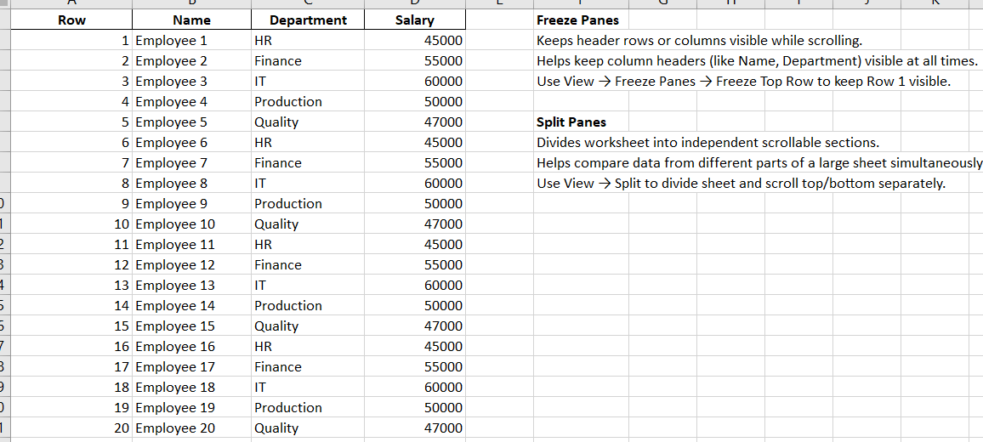

Question 3: Explain the difference between inserting a new row and inserting a new column in Excel. Can you insert multiple rows or columns at once?

**1. Inserting a New Row**

* **Function:** Adds a new **horizontal line** of cells **below** the selected row.
* **Effect:** Shifts the **existing rows downward**.
* **Example:**  
  If you right-click **Row 5** and choose **Insert**, Excel adds a blank **Row 5**, and the old Row 5 becomes **Row 6**.

**2. Inserting a New Column**

* **Function:** Adds a new **vertical line** of cells **to the left** of the selected column.
* **Effect:** Shifts the **existing columns to the right**.
* **Example:**  
  If you right-click **Column C** and choose **Insert**, Excel adds a blank **Column C**, and the old Column C becomes **Column D**.

**3. Inserting Multiple Rows or Columns**

**Yes**, you can insert **multiple rows or columns at once.**

**Methods:**

* **Select multiple rows/columns** before inserting.
  + Example: Select **Rows 5 to 7**, right-click → **Insert** → Excel adds **3 new blank rows**.
* Or use the **Home → Insert → Insert Sheet Rows/Columns** option.

**Question 4: What are logical functions in Excel? Provide examples of at least two logical functions and their applications.**

Logical functions in **Excel** are used to test conditions and return results based on whether the condition is **TRUE** or **FALSE**.  
They help automate decision-making in worksheets.

| **Function** | **Purpose** | **Example** | **Result** |
| --- | --- | --- | --- |
| **IF** | Checks one condition and returns a value if TRUE or FALSE | =IF(A1>50,"Pass","Fail") | Shows *Pass* if A1 > 50, otherwise *Fail* |
| **AND** | Checks if *all* conditions are TRUE | =AND(A1>50,B1>60) | TRUE only if both conditions are met |
| **OR** | Checks if *any* condition is TRUE | =OR(A1>50,B1>60) | TRUE if either condition is met |
| **NOT** | Reverses a logical value | =NOT(A1>50) | TRUE if A1 ≤ 50 |

**Question 5: Discuss the purpose of 'XLOOKUP' and how it differs from the traditional 'VLOOKUP' function.**

Purpose of XLOOKUP: -

* To find and return a value from a table or range based on a lookup value.
* It can search in any direction — left, right, up, or down.
* It also handles exact and approximate matches, and even missing values gracefully.

| **Feature** | **VLOOKUP** | **XLOOKUP** |
| --- | --- | --- |
| **Lookup Direction** | Searches **only to the right** of the lookup column | Can search **left or right**, **up or down** |
| **Column Reference** | Requires column **index number** | Uses **direct range references** |
| **Performance** | Slower with large data sets | Faster and more efficient |
| **Error Handling** | Returns #N/A if not found | Allows custom “not found” message |
| **Default Match** | Approximate match (if not specified) | Exact match by default |
| **Availability** | Older Excel versions | Excel 2021 and Microsoft 365 |

**Question 6: Create a worksheet titled 'Employee Data' with columns: Name, Age, Department. Add 5 rows of data.**

Here’s a worksheet attached with titled 'Employee Data' with columns: Name, Age, Department and 5 rows of data has been added.

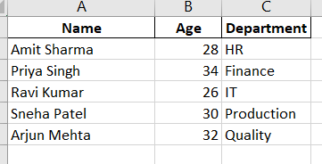

**Question 7: Demonstrate how to insert and delete multiple rows and columns in Excel.**

| **Action** | **How to Select** | **Effect** |
| --- | --- | --- |
| Insert multiple rows | Select multiple rows → Right-click → Insert | Adds blank rows above selection |
| Insert multiple columns | Select multiple columns → Right-click → Insert | Adds blank columns to the left |
| Delete multiple rows | Select multiple rows → Right-click → Delete | Removes rows, shifts remaining up |
| Delete multiple columns | Select multiple columns → Right-click → Delete | Removes columns, shifts remaining left |

**Before**

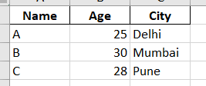

**After Inserting rows**

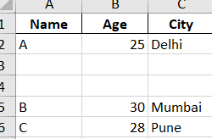

**After inserting a column**

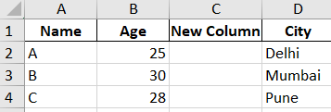

**After deleting columns**

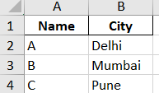

**Question 8: Use Excel's 'Find and Replace' feature to update department names in a sample table.**

**Before Find and replace**

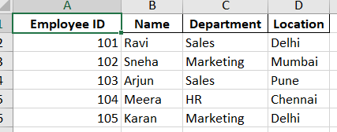

**After Find and Replace**

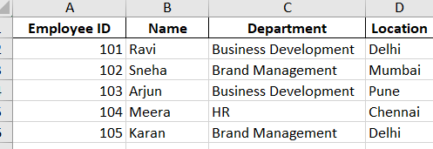

**Question 9: Create a small numerical dataset and apply the following functions: ● AVERAGE ● MAX ● MIN**

Here’s a small dataset which calculates the average, maximum and minimum values.

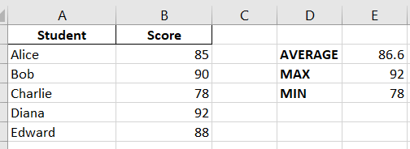

**Question 10: You're working with a dataset that contains missing values. As a Data Scientist, explain how you'd detect and handle missing data using Excel. Mention tools like: ● Go to Special ● ISBLANK ● COUNTBLANK**

1. Detecting Missing Values

**a) Using “Go To Special”**

* Select the dataset or the column you want to check.
* Press F5 → Click Special… → Select Blanks → Click OK.
* Excel will highlight all blank cells in the selected range.
* You can now fill them, delete them, or take other actions.
* Use case: Quickly visualizing all missing values in large datasets.

**b) Using ISBLANK Function**

* Syntax: = ISBLANK(cell)
* Returns TRUE if the cell is empty, otherwise FALSE
* Use case: Helpful for creating a new column to mark missing values.

**c) Using COUNTBLANK Function**

* Syntax: =COUNTBLANK(range)
* Counts the number of empty cells in a range.
* Returns the total number of missing values in that column.
* Use case: Summarizing missing data to understand the dataset completeness.

**2. Handling Missing Values**

Once missing data is detected, you have a few options:

**a) Delete Rows or Columns**

* If only a few rows have missing values, you can delete them using **Go To Special → Blanks → Delete**.
* Be careful: Removing too many rows can bias your dataset.

**b) Fill Missing Values**

* **Manually**: Enter values directly.
* **Automatically**:

1. Fill with **0** or a constant value.
2. Fill with **mean/median/mode** of the column
3. Use **Flash Fill** or formulas to propagate values.

**c) Conditional Handling**

* Create a helper column to flag missing values:

**Here in the below excel sheet, the above tools are used.**

